**Update**

In their latest release dated 4th January, OpenAI shut down older completions and embeddings models, including the following models:

* text-davinci-003
* text-davinci-002
* ada
* babbage
* curie
* davinci
* text-ada-001
* text-babbage-001
* text-curie-001
* text-davinci-001

The following includes all of the models which will be turned off on January 4th:

* text-ada-001
* text-babbage-001
* text-curie-001
* text-davinci-001
* text-davinci-002
* text-davinci-003
* davinci-instruct-beta
* curie-instruct-beta
* code-search-ada-code-001
* code-search-ada-text-001
* code-search-babbage-code-001
* code-search-babbage-text-001
* text-search-ada-doc-001
* text-search-ada-query-001
* text-search-babbage-doc-001
* text-search-babbage-query-001
* text-search-curie-doc-001
* text-search-curie-query-001
* text-search-davinci-doc-001
* text-search-davinci-query-001
* text-similarity-ada-001
* text-similarity-babbage-001
* text-similarity-curie-001
* text-similarity-davinci-001
* text-davinci-edit-001
* code-davinci-edit-001
* text-davinci-insert-001
* text-davinci-insert-002

**Please refer to the below instructions in order to continue with your learning journey -**

The effect on deprecations is likely to be influenced by the version of Shell-GPT or other tools being used by the customers.

To test, we downloaded the latest version of Shell-GPT from its GitHub repository (Version 1.1.0) and the below screenshot shows it automatically defaults to a non-deprecated/recommended replacement version outlined by OpenAI [here](https://platform.openai.com/docs/deprecations).

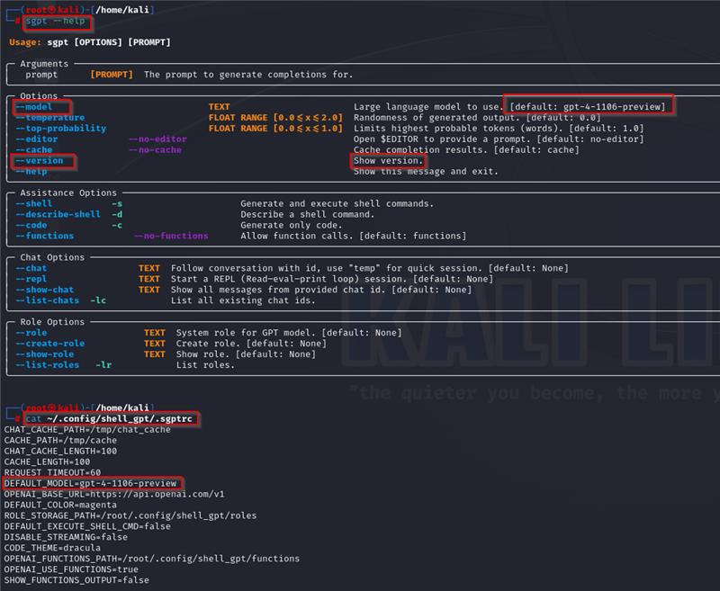

In the event the customers need to update the model used by a tool like Shell-GPT, below are a few options:

**1. Modify Default Model -**

Update the default model used by the tool by modifying the source file. If you're using Shell-GPT, follow these simple steps:

vi | nano ~/.config/shell_gpt/.sgptrc

Edit the Default Model section of the file

Save the file

**2. Upgrade the Tool -**

Update the tool to check for a new/supported default model. For Shell-GPT execute the below command:

pip install --upgrade shell-gpt

cat ~/.config/shell_gpt/.sgptrc

**3. Reinstall for Fresh Configuration -**

Consider removing and redownloading the tool to determine if a supported default model is configured with the current version. Below is the link to the GitHub repository of Shell-GPT

<https://github.com/TheR1D/shell_gpt>